**IT491** – Cloud Computing **Date** – March 20, 2023

**Lab Report - 4**

**Name** – Divya Kirtikumar Patel

**Student ID** - **202001420**

**Build a API for Table app with Python SDK and Azure Cosmos DB**

1. **Login Azure**

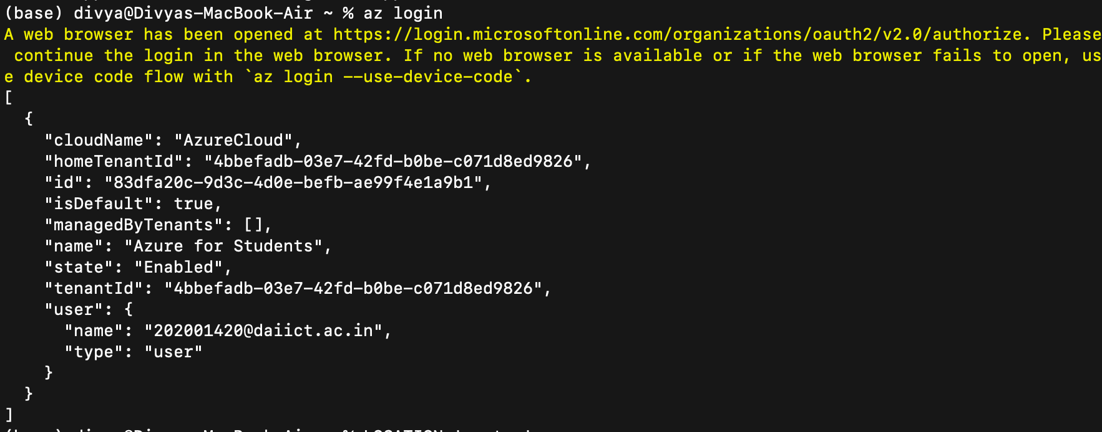

1. **Make Resource Group**

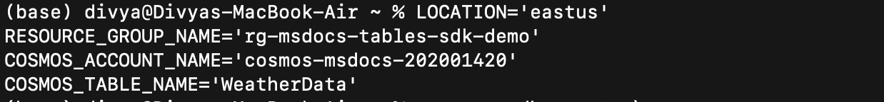

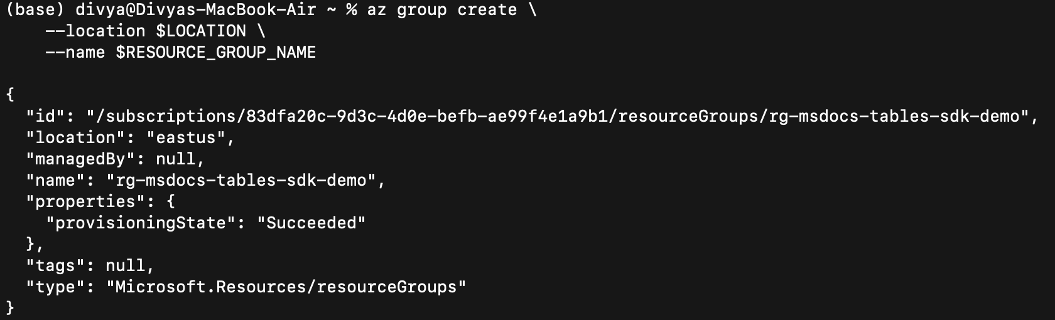

1. **Create CosmosDB**

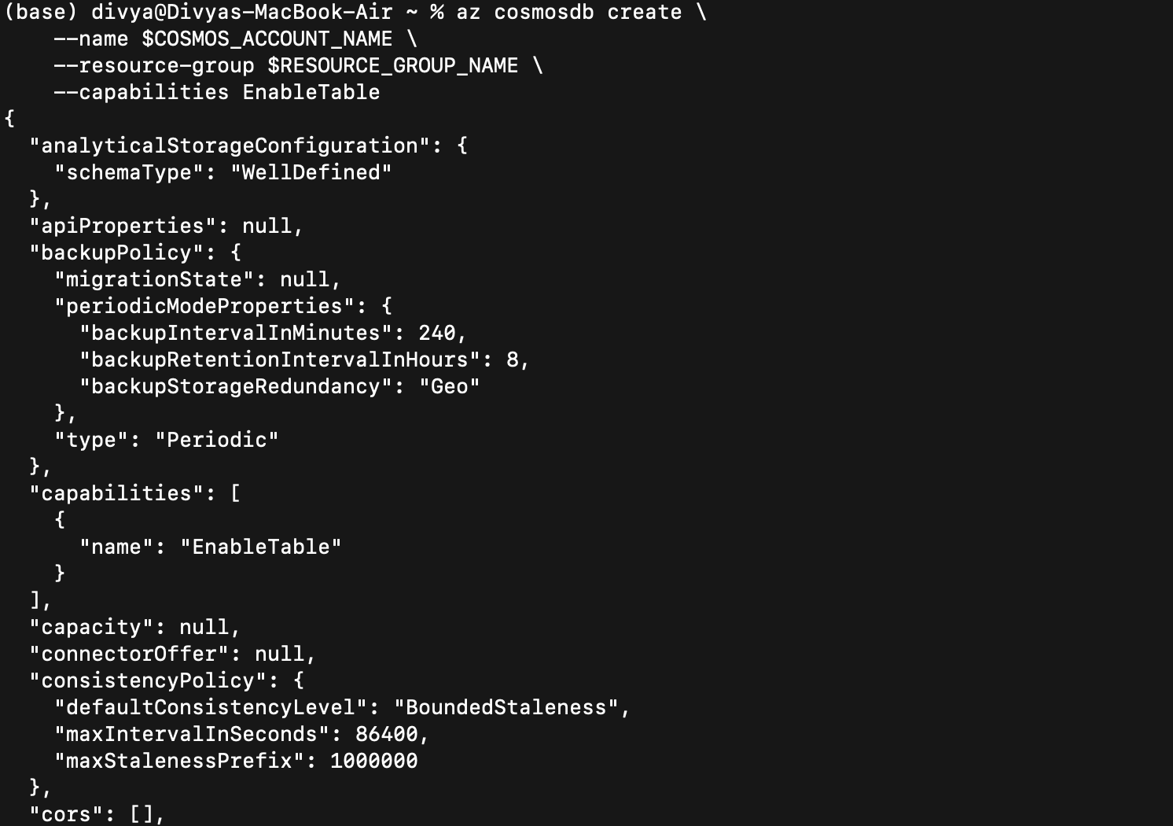

**Resource group and CosmosDB on Azure Portal**

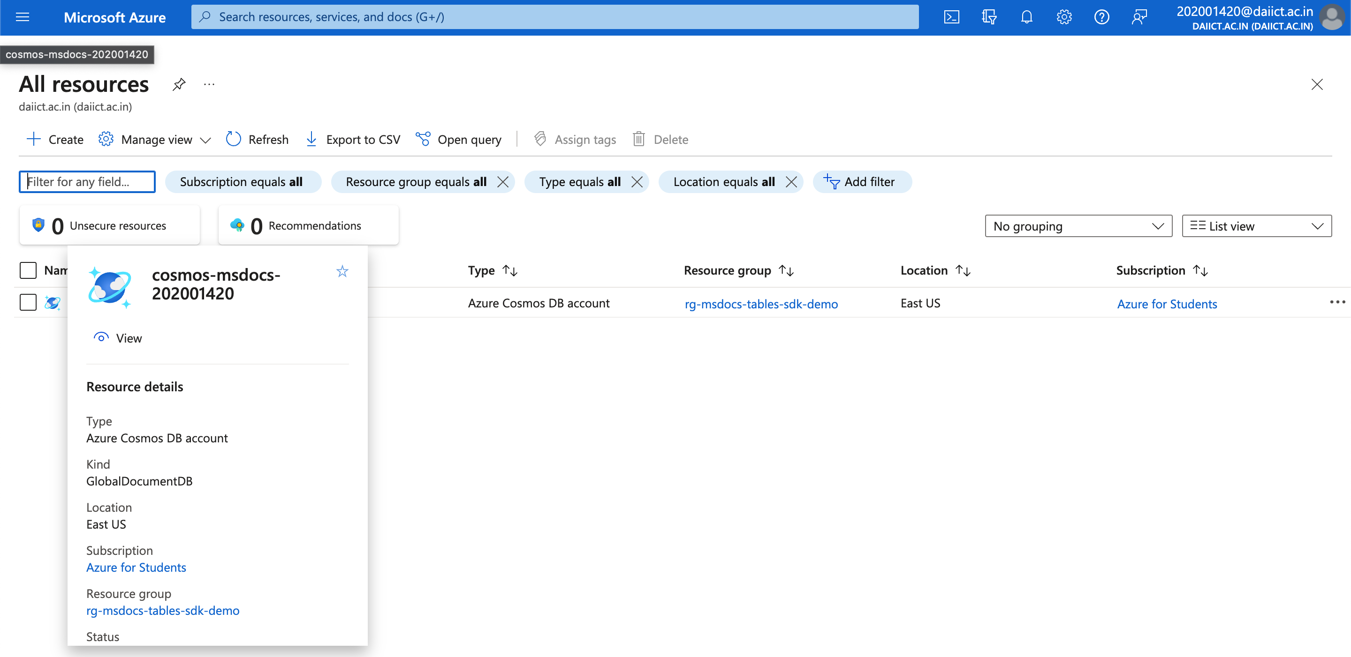

1. **Create Table in CosmosDB**

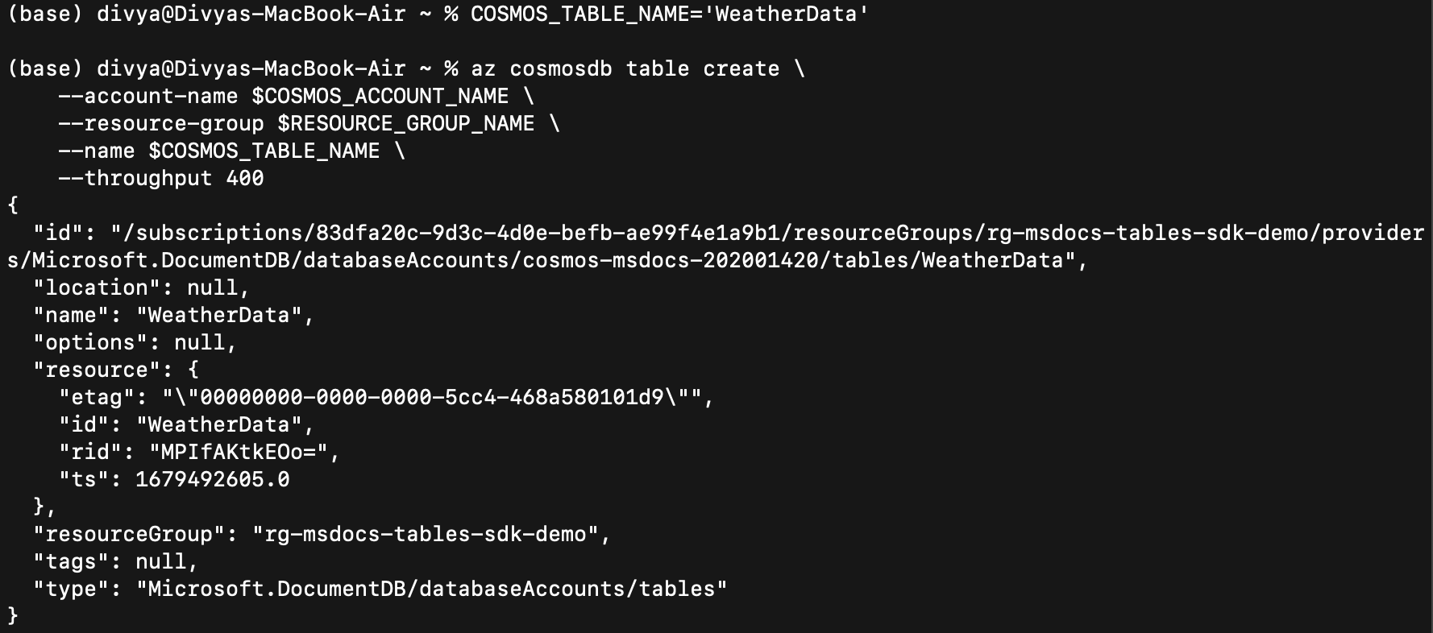

1. **Get Connection strings**

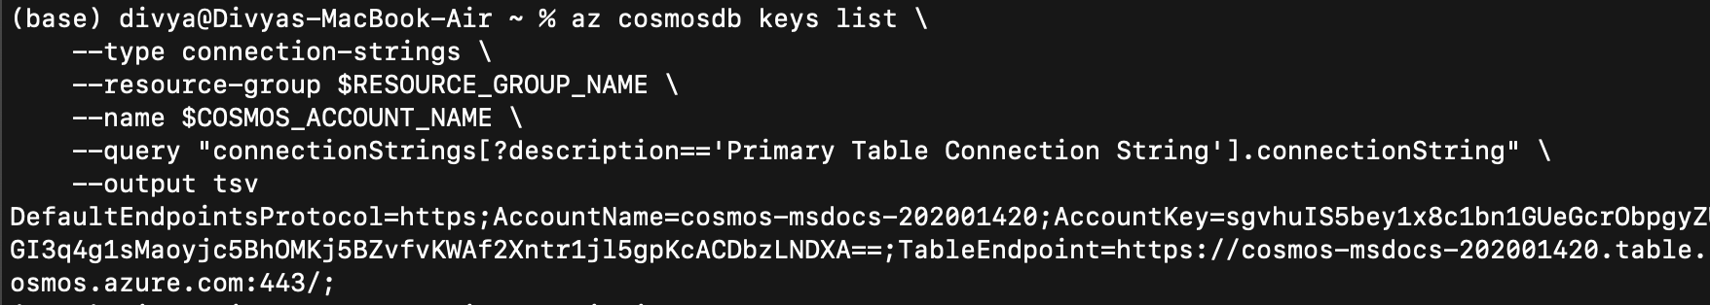

1. **Run the application from Github**

**Clone github repo and Configure Parameters in the .env file**

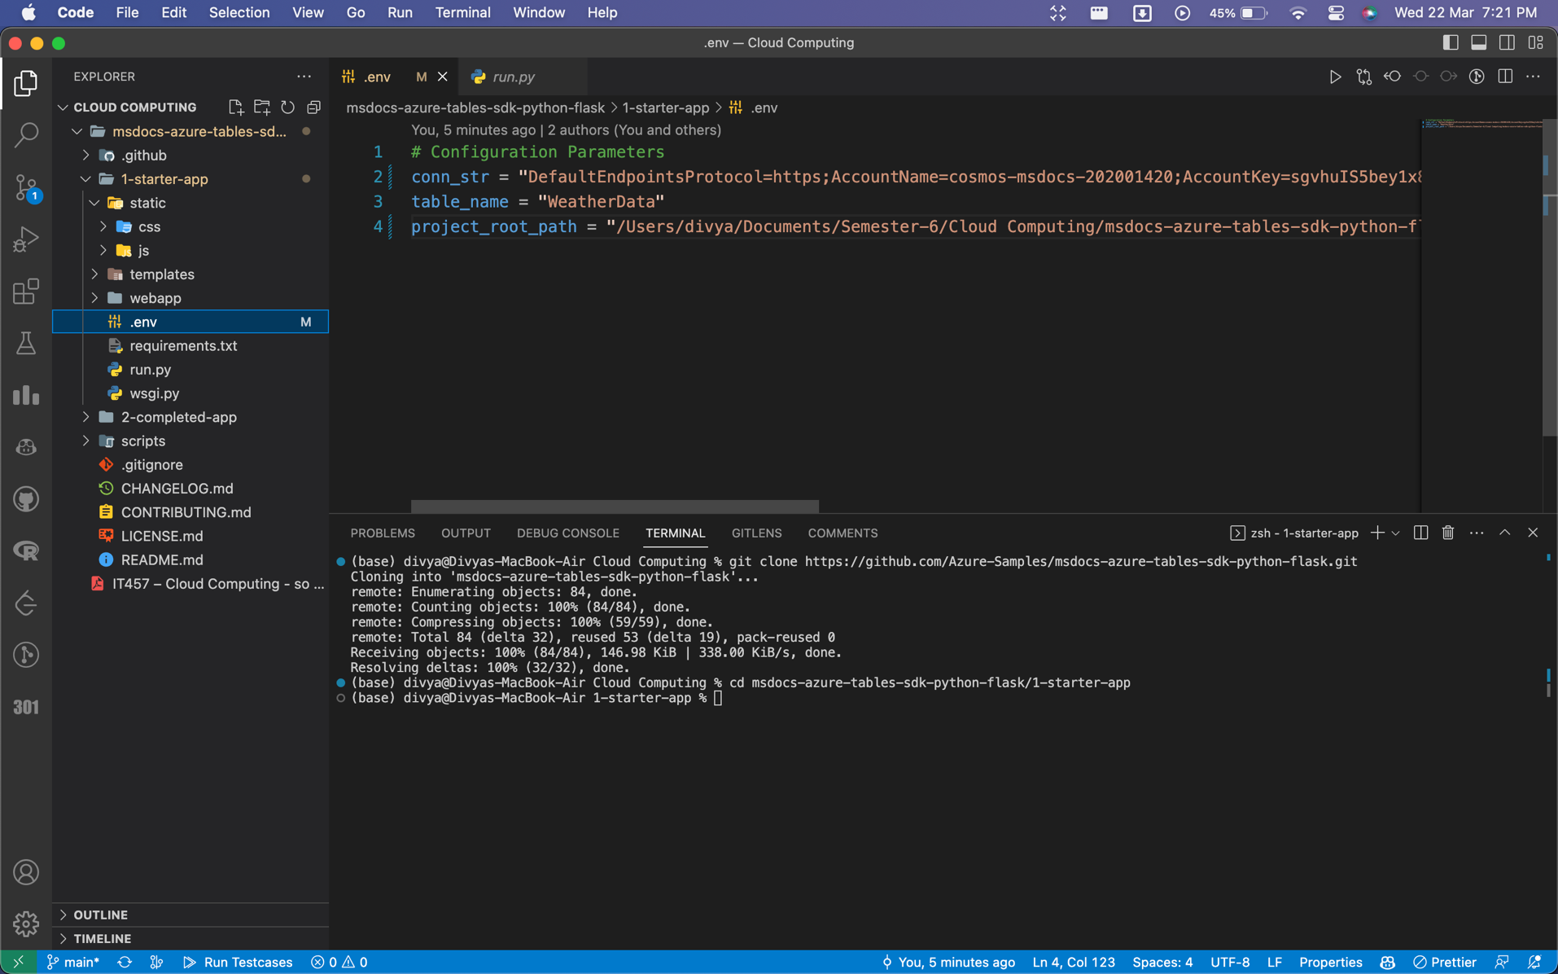

**Update functions in the helper.py file**

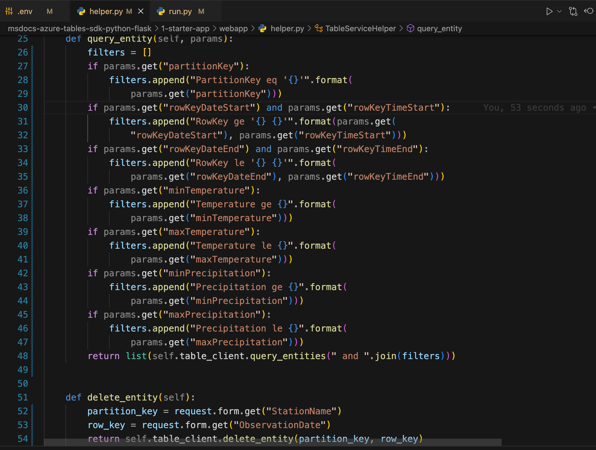

**Run the app on port 8000:**

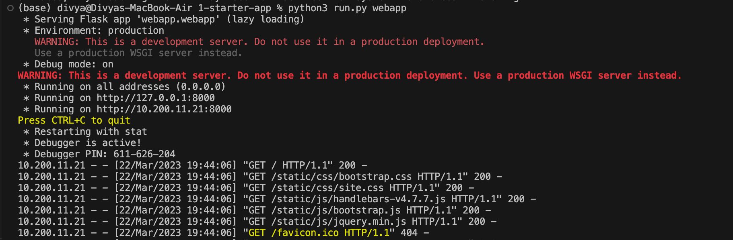

**Application Screen:**

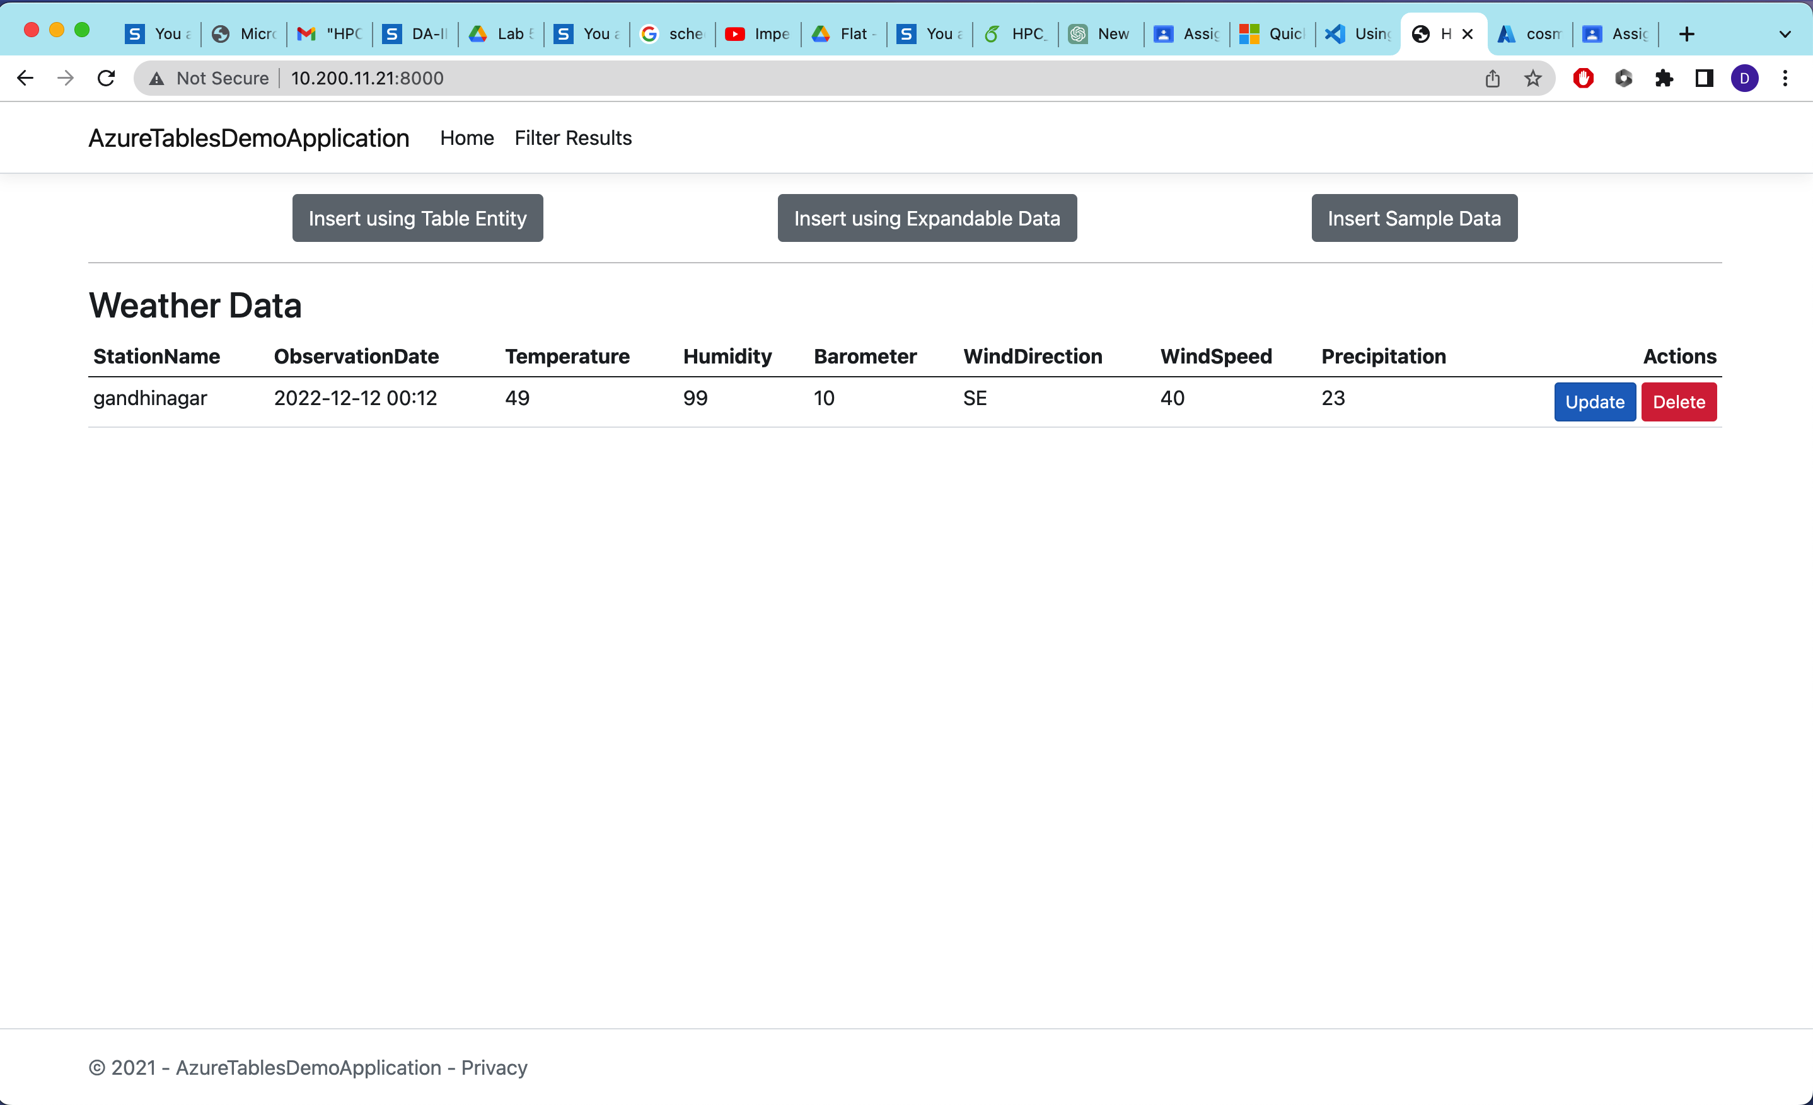

**Results on Azure portal:**

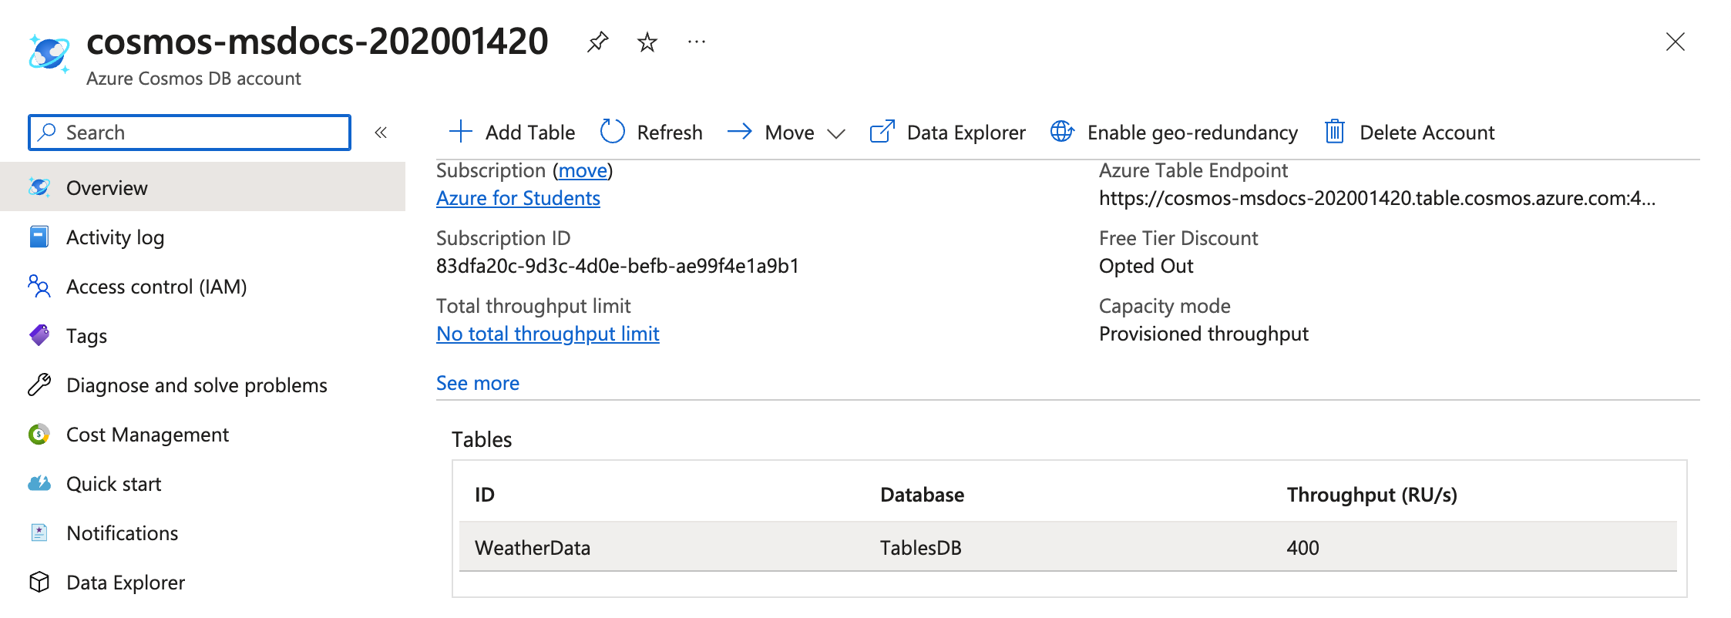

**The entry is visible on Azure Portal:**

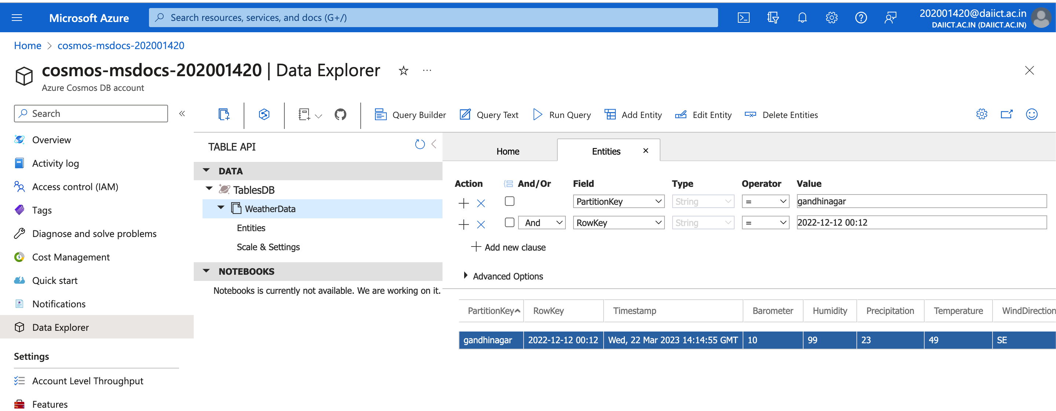

**Inserting Sample Data :**

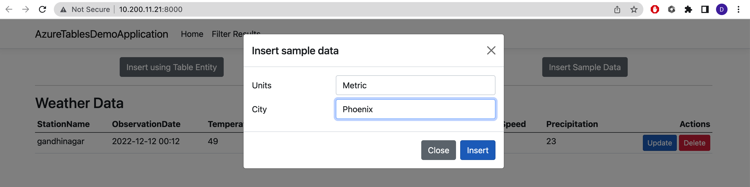

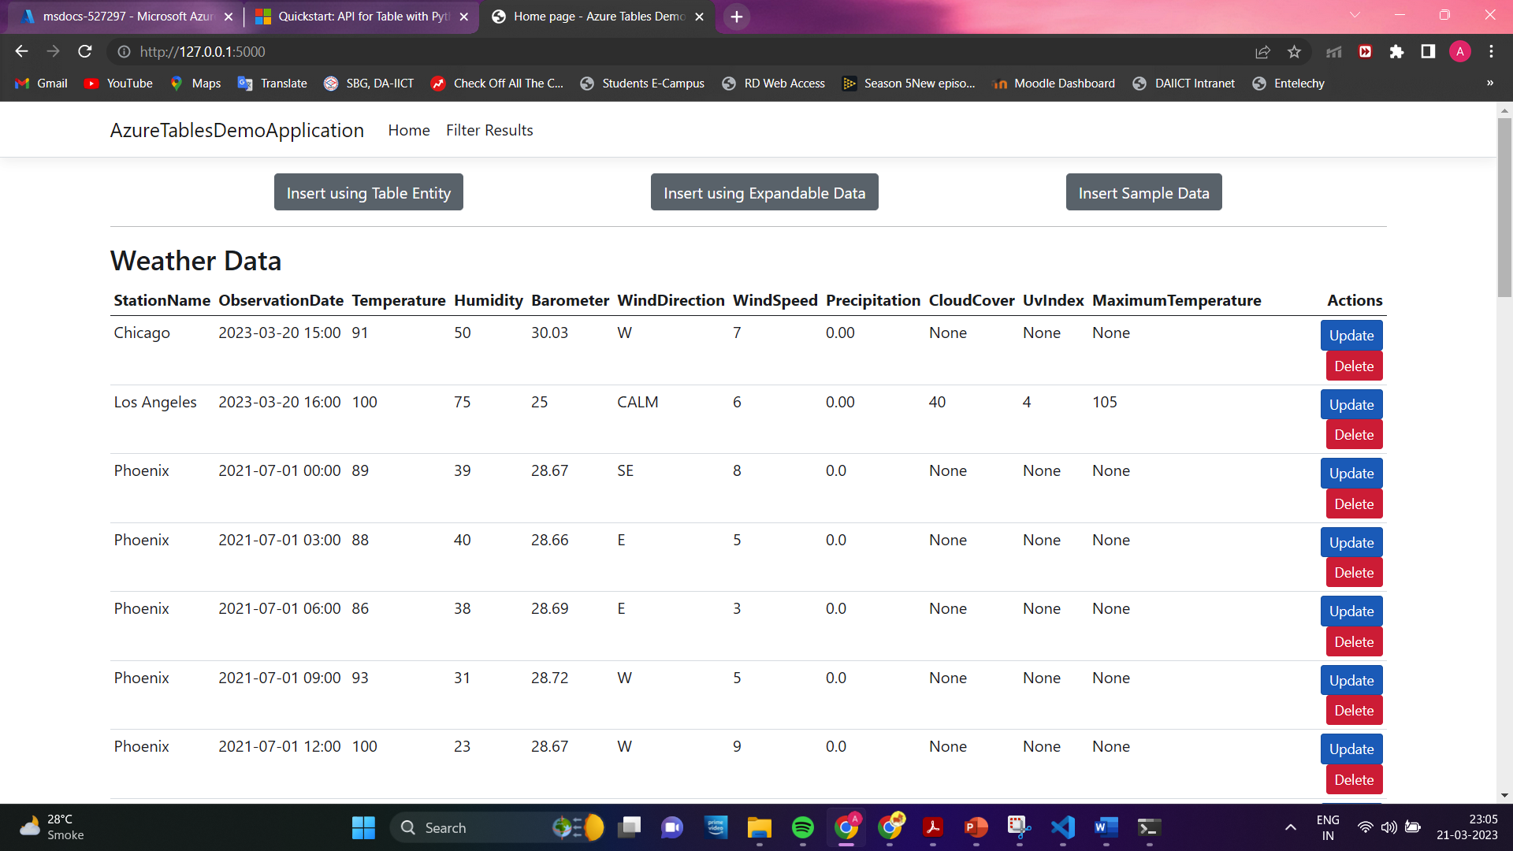

**Azure Portal:**

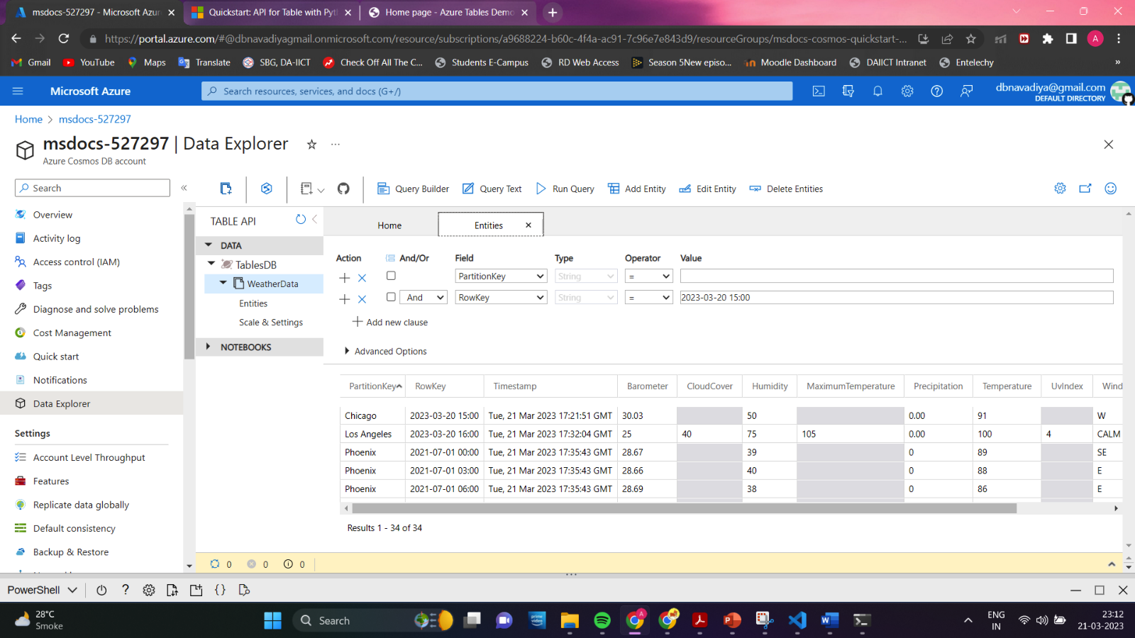

**Clean-up Resources:**

